Contents
Former PFI Users 2
Registering 4
Forgot Password 6
How Do I Add Students To My Account? 7
What is my child eating 9
Meal restrictions 10
How do I Add or Edit My Payment Methods? 11
How Do I Make A Lunch Payment? 14
Make One Time Lunch Payment 14
Auto Replenishment 16
How Do I Configure Email Options For My Account? 18
How Do I Make Fee Payments? 21
How Do I Schedule Fee Payments/Installments? 23
Payment History 24
Running Reports 24
Patron Account Activity Report 25
Patron Fund Account Activity 25

Former PFI Users

- If you previously went to the www.PayForIt.net site to access your account, your information has been migrated over to PaySchoolsCentral.com!
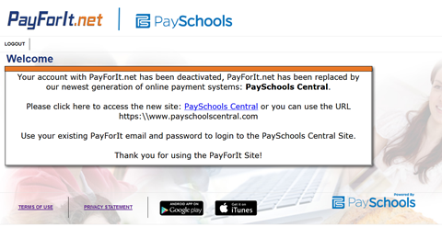

- Clicking the link will re-direct the user to PaySchools Central login page
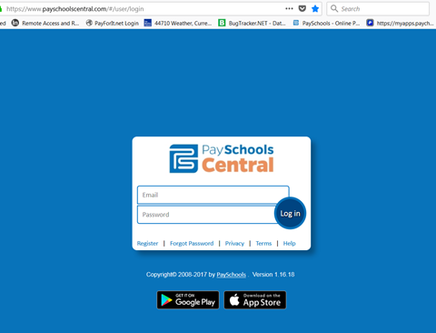

- The following pop-up will display upon login. Just confirm your information and Continue to Dashboard! When you sign in with your credentials, any information that was migrated will be displayed in the message below.

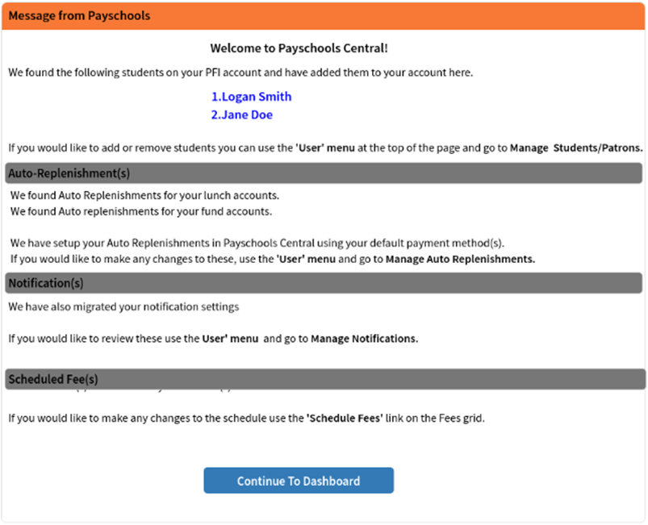

Registering

- To register, go to payschoolscentral.com and select the Register option below the Email and Password fields.
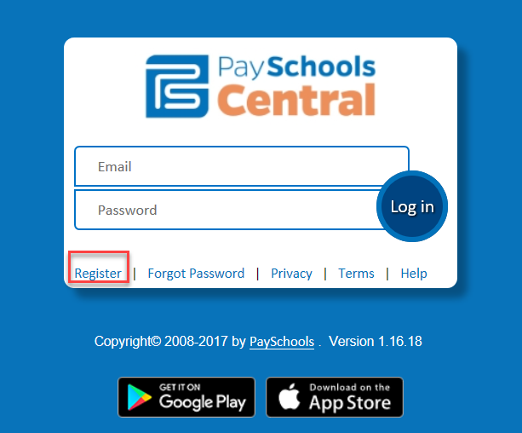

- Once on the ‘New User Registration’ page, fill out all required fields marked by a red asterisk. Be sure to check the User Agreement and click the box before selecting Register.
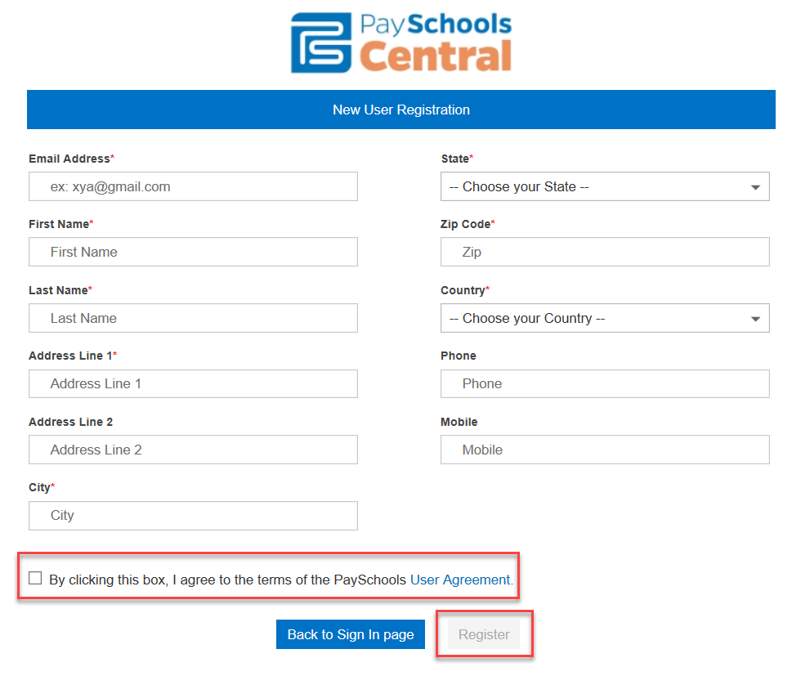

- Once the Register button is selected an email will be delivered to your email account with a link to activate your account and set your password. This link is ONLY VALID FOR 30 MINUTES. If you do not activate the link within the allotted time, please return to payschoolscentral.com and use the Forgot Password link to request a new email.
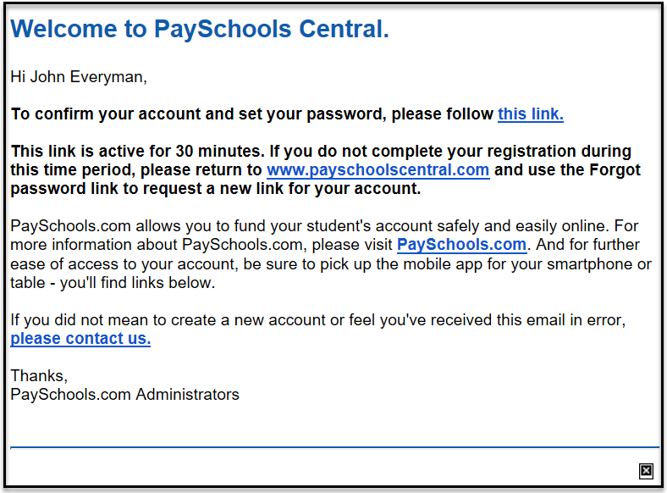
- You will then enter your email, password, and confirm to complete registration.
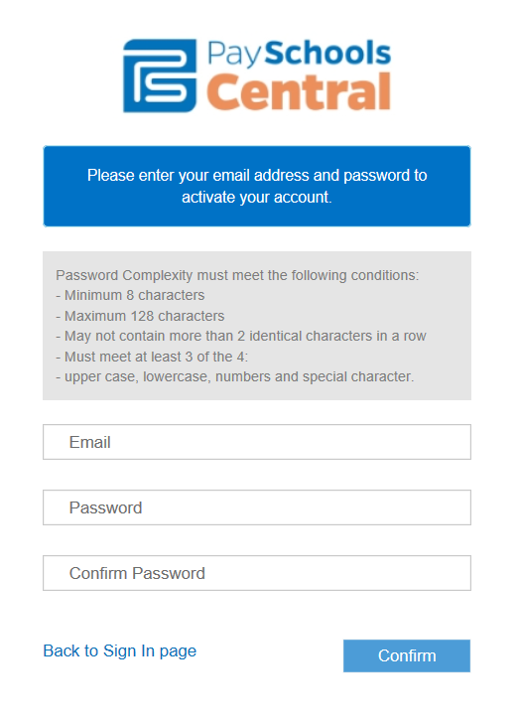

Forgot Password

- If you forget your password, use the Forgot Password link on the login page.

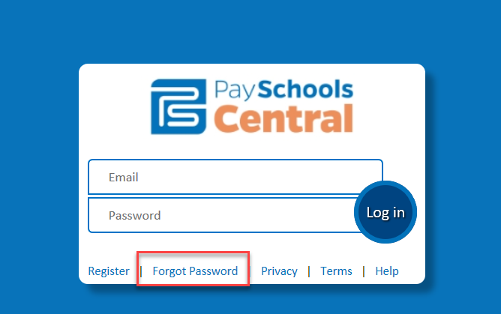
- From here, choose whether you would like to receive an email link or a text code to reset your password.
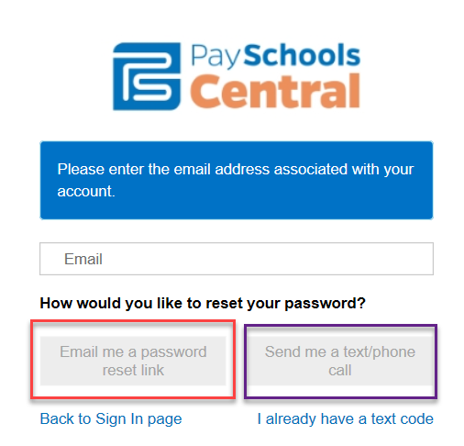

How Do I Add Students To My Account?

You can set up as many students as needed through a single account, as long as they are within the same district. For reporting purposes, and other reasons, the system is unable to create an account for two (2) students with two (2) different districts. You must create separate accounts, listing a different district, and use a different email for each.

Step 1 – Adding a Student

- Upon logging into the system for the first time, you will be prompted to add a patron to your account. Follow the Click Here link, then the Add Student/Patron button to add your student’s information.

A)
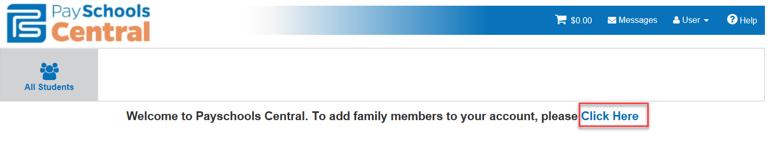

B)

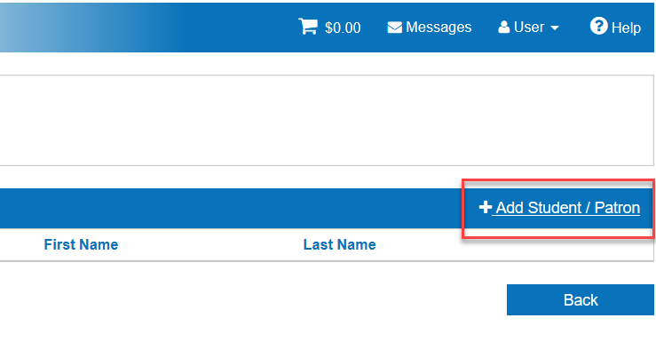

Step 2 – Enter Student Information

- Your student’s information must match the details provided to you at registration by your school. PaySchools CANNOT provide student information and any questions pertaining to student information must be directed to your school.

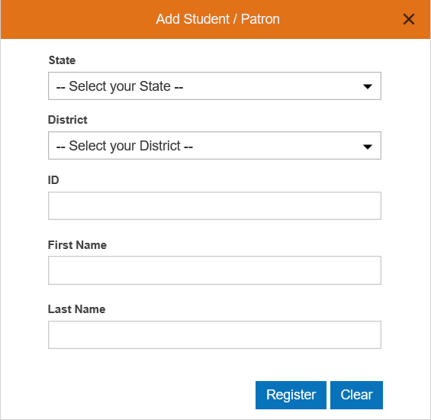

- Once all information has been entered, press the Register button.

Step 3 – View Added Student
- Click the PaySchools Central logo in the upper-left corner of your screen to return to the home page.

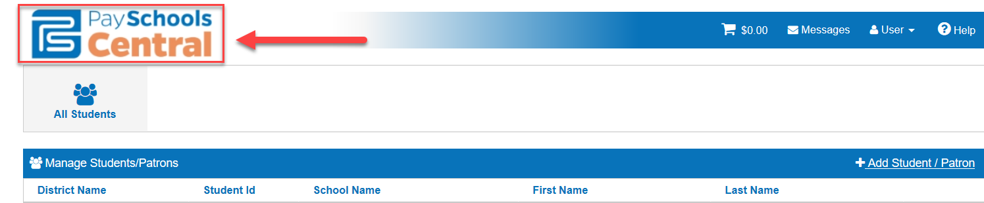

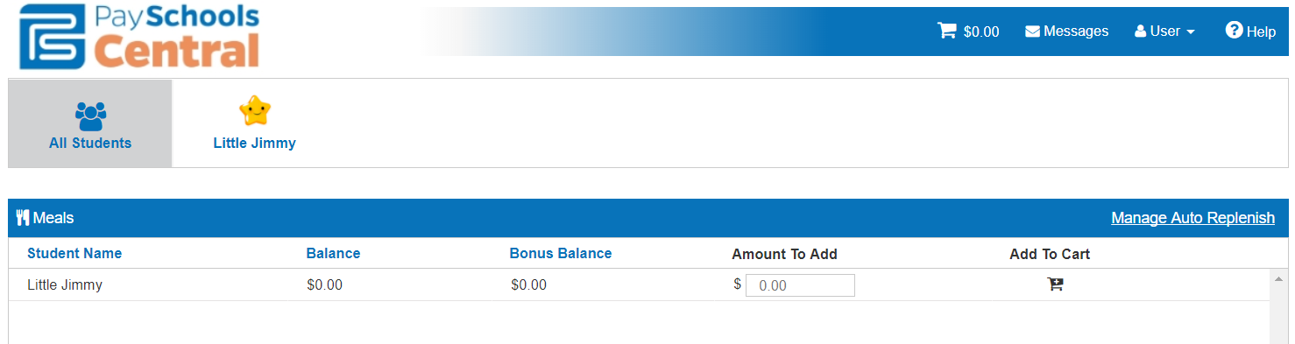

- Click on the specific student name to see additional settings:
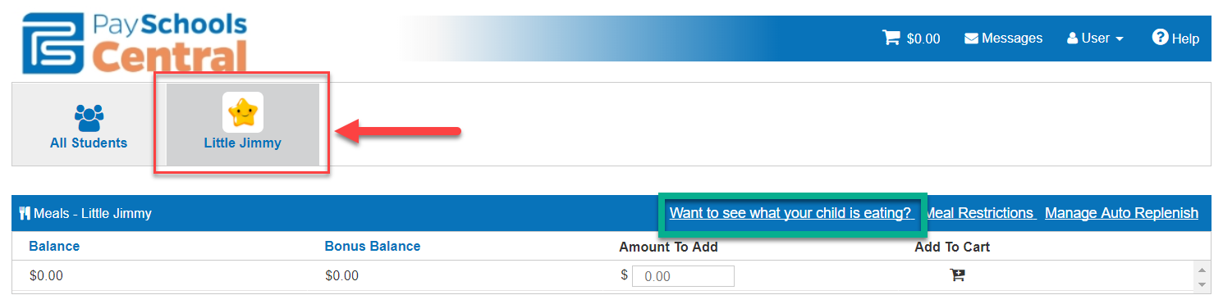

What is my child eating

- Want to see what your child is eating? will tell you the item and price of the food your student is purchasing.
- Select the dates you want to see, and the activity will populate below and the PDF icon in the upper right will allow you to export the report.
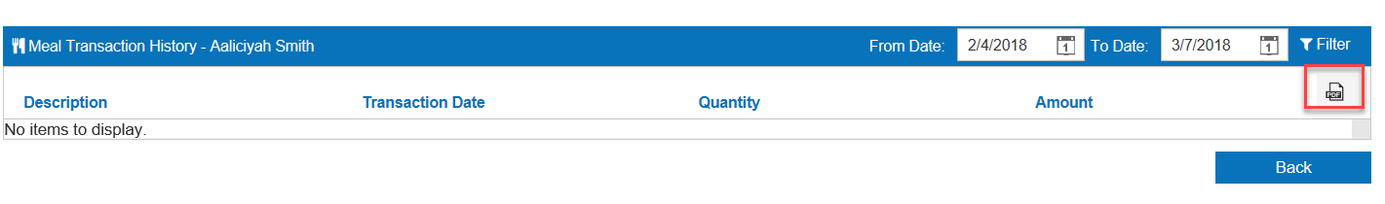

Meal restrictions
- The Meal Restrictions option will allow you to decide a ‘Daily Spending Limit’, other meal period specific restrictions, as well as specific ‘Item Groups’ and ‘Items’.

Note: The ability to manage these is contingent on your school or district being equipped with the proper software, or the permissions allowed to you by the school or district.

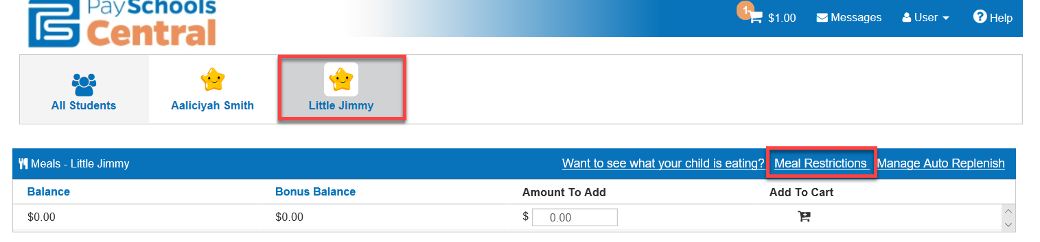

- You can make your selections from the page shown below. Once you have set your restrictions, press the Save button.
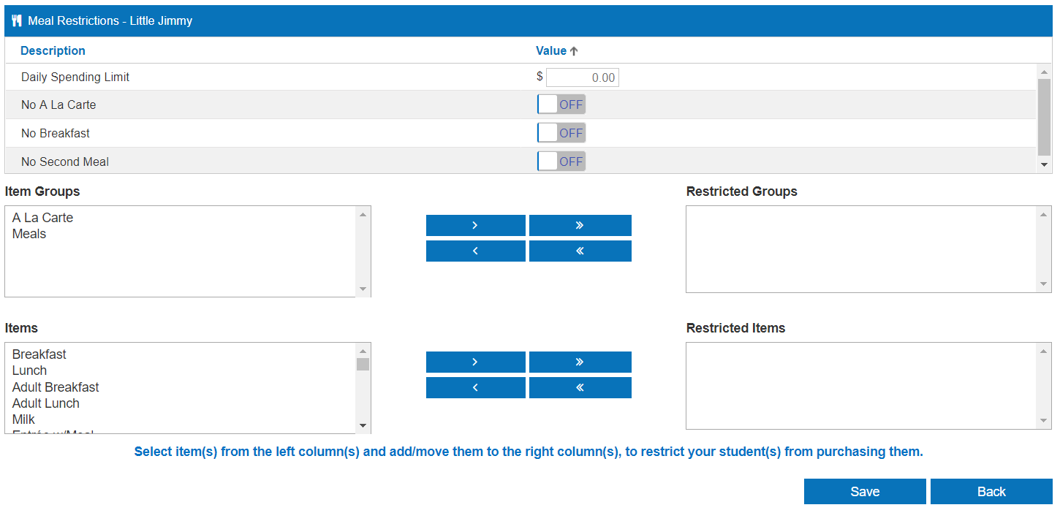

How do I Add or Edit My Payment Methods?

With PaySchoolsCentral.com, you have the ability to store multiple credit card numbers in the system. You can choose which card you want to use with each transaction that you make. You can also enter your banking information to opt to pay transactions by electronic check (commonly known as “ACH”). Your school district may not offer both options, in that case, you will only see one choice.

To add credit card numbers or banking information, follow these steps:

Step 1 – User Manage Payment Methods Add New Payment
- To configure your payment methods from the homepage, press My Account and choose My Payment Methods.

a)
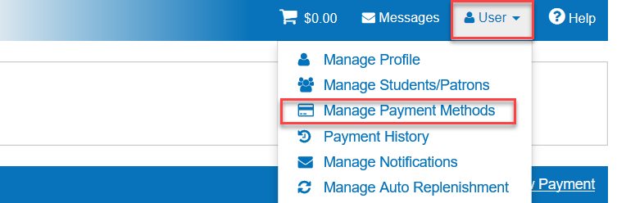
b)
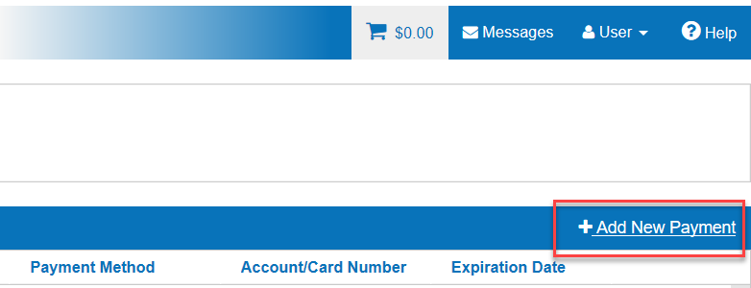

Step 2 – Select and enter payment method options
- Use the Choose Payment Type dropdown menu, to indicate what type of payment method to add. Be sure to enter a Nick Name for your payment option to help identify your payment method at checkout. Please Note: This cannot have any special characters.

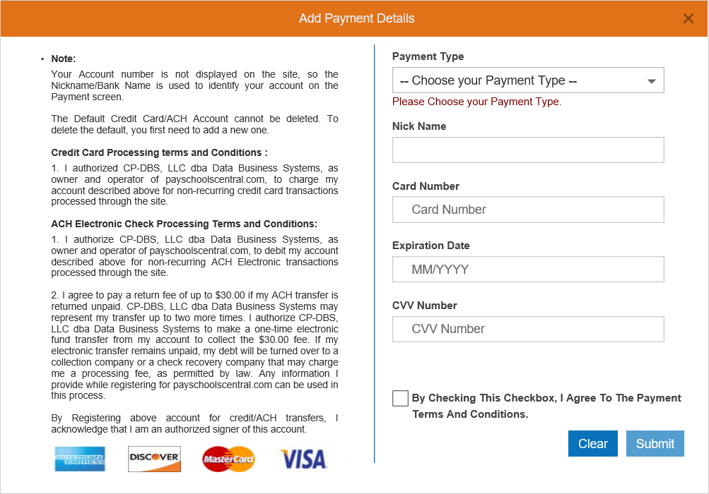
- Depending on your selection of credit/debit card or ACH, the information needed will be displayed. Enter your information into each field.
Credit/Debit Card
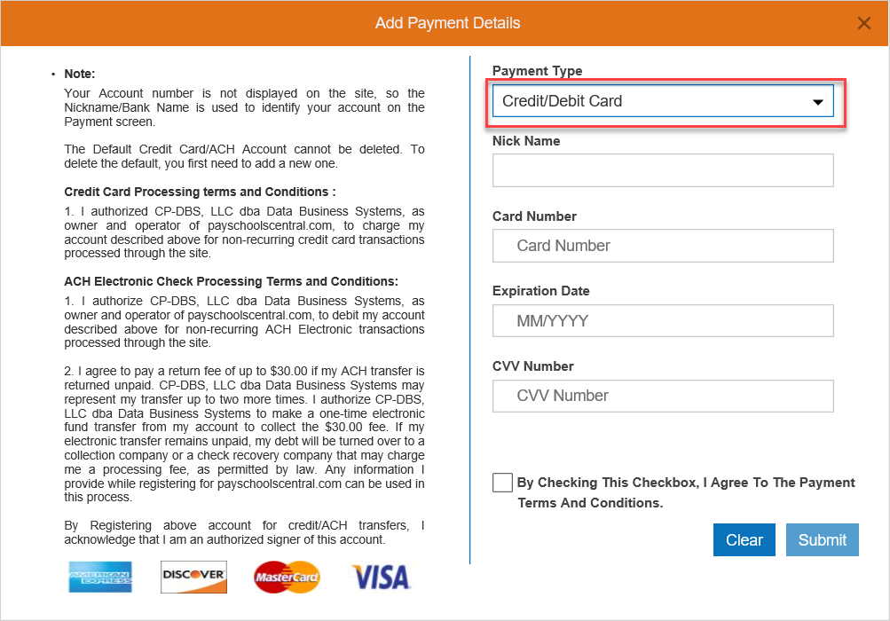

ACH
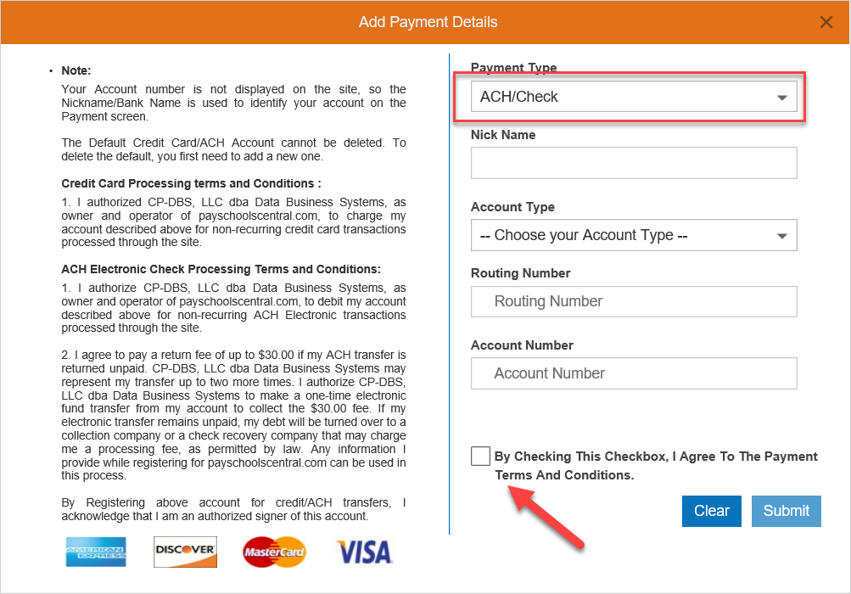

- Press the By Checking This Checkbox to agree to terms and conditions
Step 3 – Choosing your payment method at checkout
- If you have decided to list multiple payment methods on your account, you now have the ability to choose which method you want to use in the Select Your Payment Type drop-down.
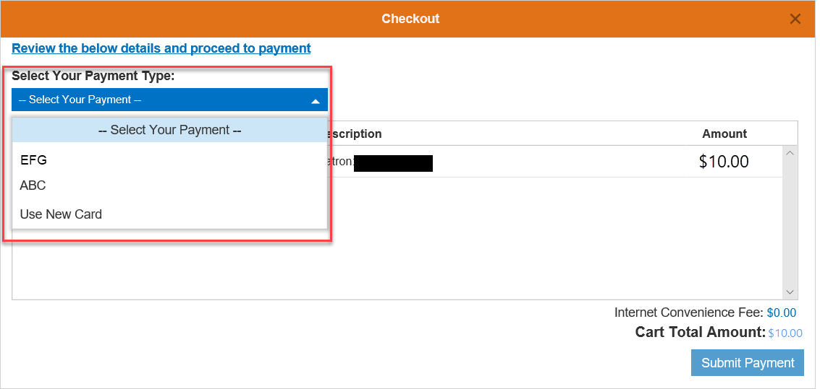

How Do I Make A Lunch Payment?

There are two ways that you can make a deposit onto your student’s lunch account.

- One is to process a one-time transaction, which will be addressed in this section.

- The second is to use our convenient auto-replenishment feature which will automatically deposit money onto your student’s account once their balance reaches a certain level.

Make One Time Lunch Payment
- To make a lunch payment from the Home Page, enter the amount you want to be deposited in the open field to the right of each student’s name.

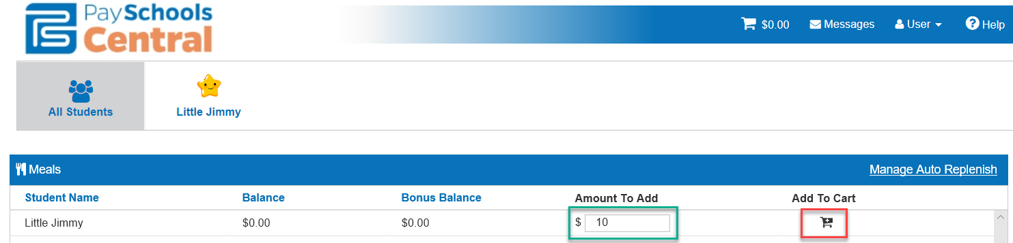

- Click the icon below Add to Cart and then confirm the amount in the pop-up. You will see the number of items, as well as the amount displayed in the cart icon at the top of your screen
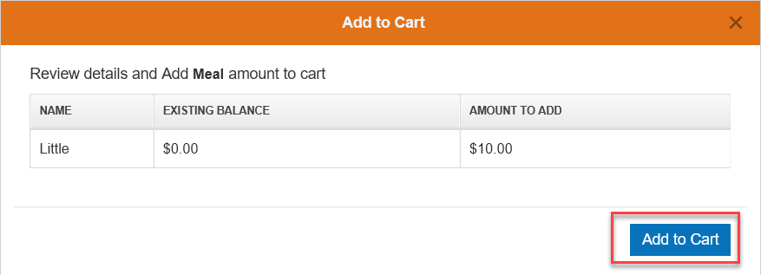
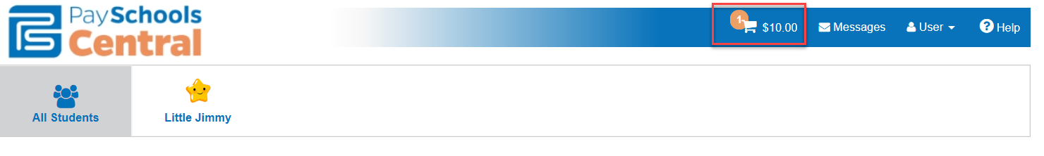

Step 2 – Process Payment

- Review the transaction before submitting it for processing.
- If you are ready to process the transaction, you need to select your desired payment method and press the Checkout button.
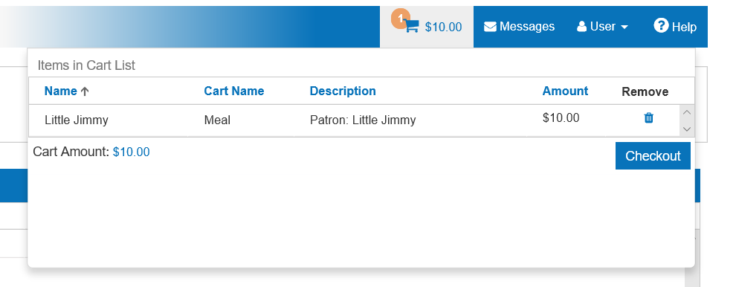

- From the Checkout pop-up, select your payment method and then Submit Payment.

- After completing your purchase, you will receive an email with a receipt listing the item and amount of your transaction.
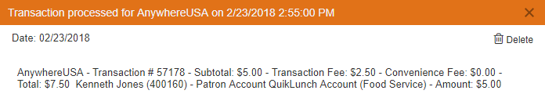

Auto Replenishment

- To turn on, or modify Auto Replenishment, first go to User -> Manage Auto Replenishment
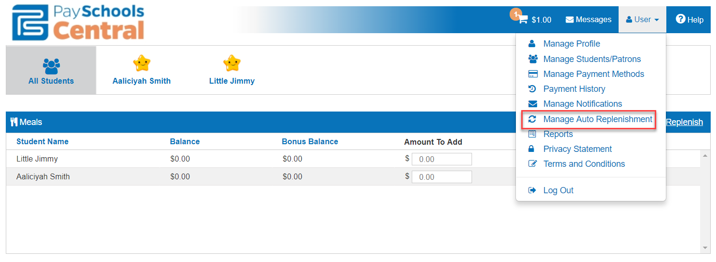

- From your list of students, choose the Balance Level (the lunch balance at which Auto Replenish will be triggered), Amount to Add (the amount to be added to the account), Stop Payments After (the date Auto Replenish will deactivate), Payment Method (this can be updated at any time), and be sure to Turn On and Save.

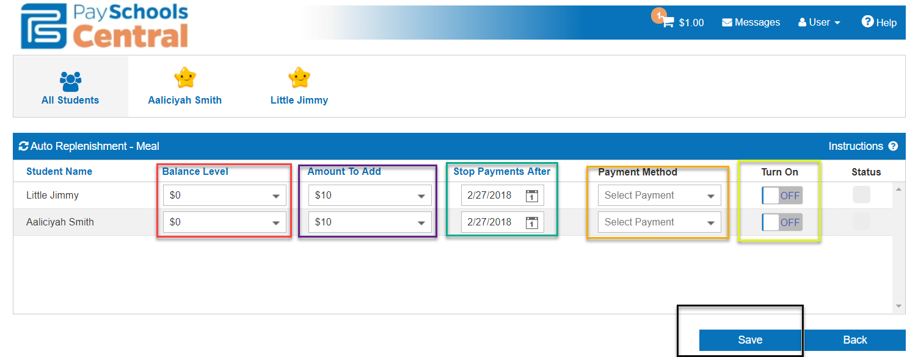

- Parents who have Auto replenishment set up for the Meal/Fund accounts now have a status indicator to alert them if a payment will be attempted today.
  - When they log in, a new status of a Green Check box will indicate that this account meets the criteria for a payment to be processed today.
  - A Red X will indicate that a payment is not needed.
  - Hovering over either of these new flags will give them more information about what the flag means. See screenshots below:
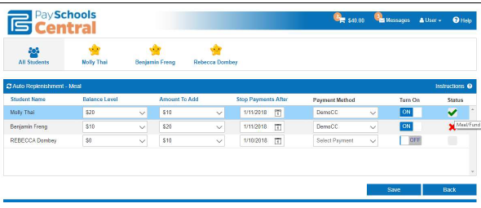

How Do I Configure Email Options For My Account?

PaySchoolsCentral.com gives you the ability to set up a variety of email options unique to your account. You have the flexibility to opt in or opt out of these options and make changes at any time. The emails will automatically be sent to the email address associated with the PaySchoolsCentral.com account.

Step 1 – UserManage Notifications

- To configure your email options from the homepage, press User and choose Manage Notifications.
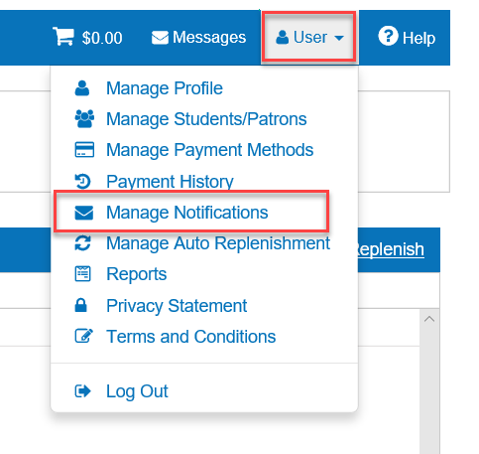

Step 2 – Email options
Each of these will provide information about your account, and a complete list is below. If your school does not offer that feature, you will not see that feature in the options:

- Low Balance: PaySchoolsCentral.com will automatically send an email when your child’s account balance reaches a predetermined balance you specify, so you know to add money to the account. Using the pull down, you can specify the amount.

- Balance Reminder: PaySchoolsCentral.com will automatically send an email on a predetermined day of the month alerting you as to your child’s account balance. You can determine which day of the month you want this reminder sent by using the pull down box.

- Fee Due: If your school is using PaySchoolsCentral.com to process school fees, then you can opt in to this email alert. PaySchoolsCentral.com will automatically send an email reminding you that your child’s school fee is due so that you can remember to make the payment in a timely fashion. You can set how far in advance you will get the notification that payment is due using the pull down box.

- Upcoming Payment: If your school is using PaySchoolsCentral.com to process school fees, then you can opt in to this email alert. PaySchoolsCentral.com will automatically send an email reminding you there is an upcoming fee payment which has been scheduled. You can determine how many days in advance you will be notified of the upcoming payment using the pull down box.

- Overdue Fee: If your school is using PaySchoolsCentral.com to process school fees, then you can opt in to this email alert. PaySchoolsCentral.com will automatically send an email if one of your fees is not paid by the due date. You can set PaySchoolsCentral.com so a notification email is sent “x” number of days after the payment is overdue.

- Monthly Statement: PaySchoolsCentral.com will automatically send you an email one day a month showing all the PaySchoolsCentral.com transactions for the month. You can determine which day of the month this is emailed to you.

Step 3 – Set Email options

- To select the email alert, simply select ON in the box to the right of the option and determine when you want to receive the alert.

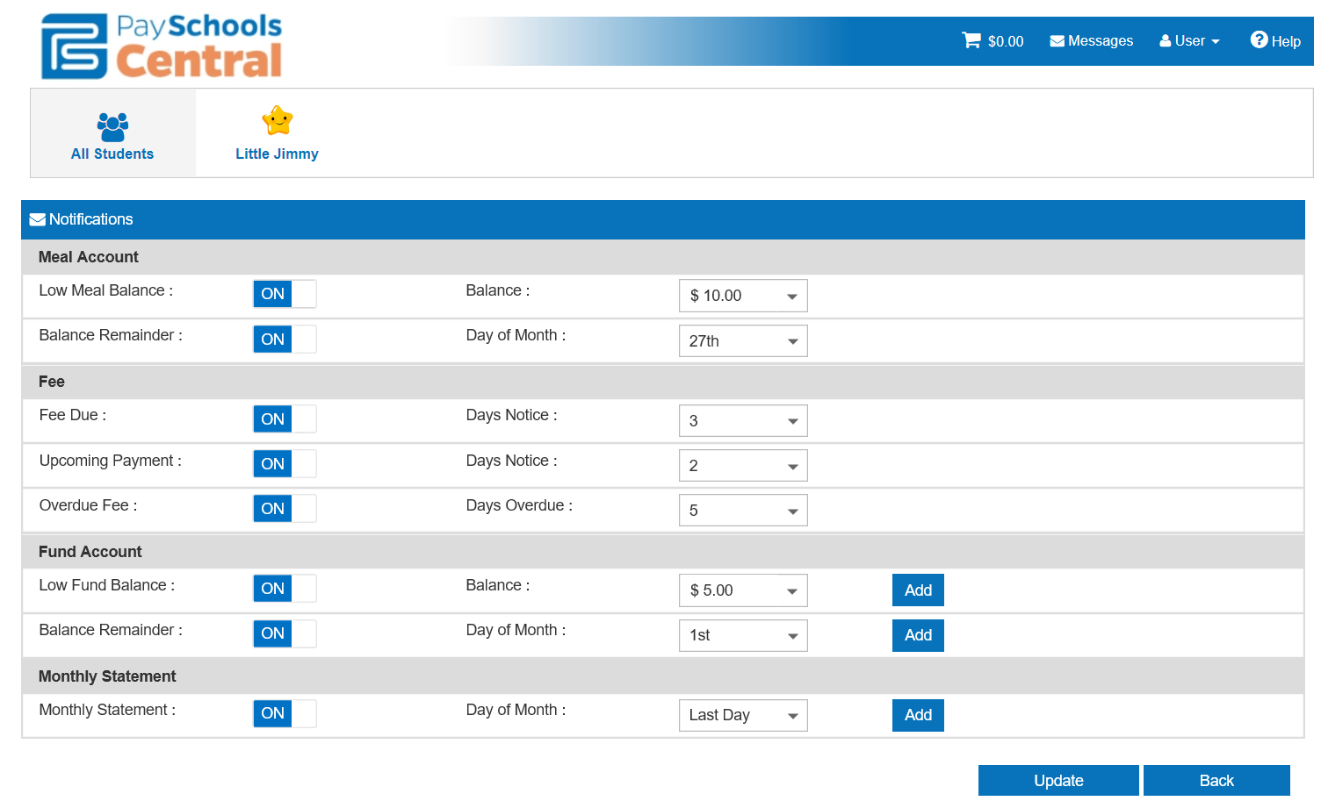

- Press the Update button, to save the settings.

How Do I Make Fee Payments?

The fees available to you are set and maintained by your School District. If you are looking for a fee that is not listed on your screen, please contact your School District.

Note: If your School District is not using the fees module in PayForIt.net, you will not see the option on your menu bar.

Step 1 – Select FeesMake Fee Payment

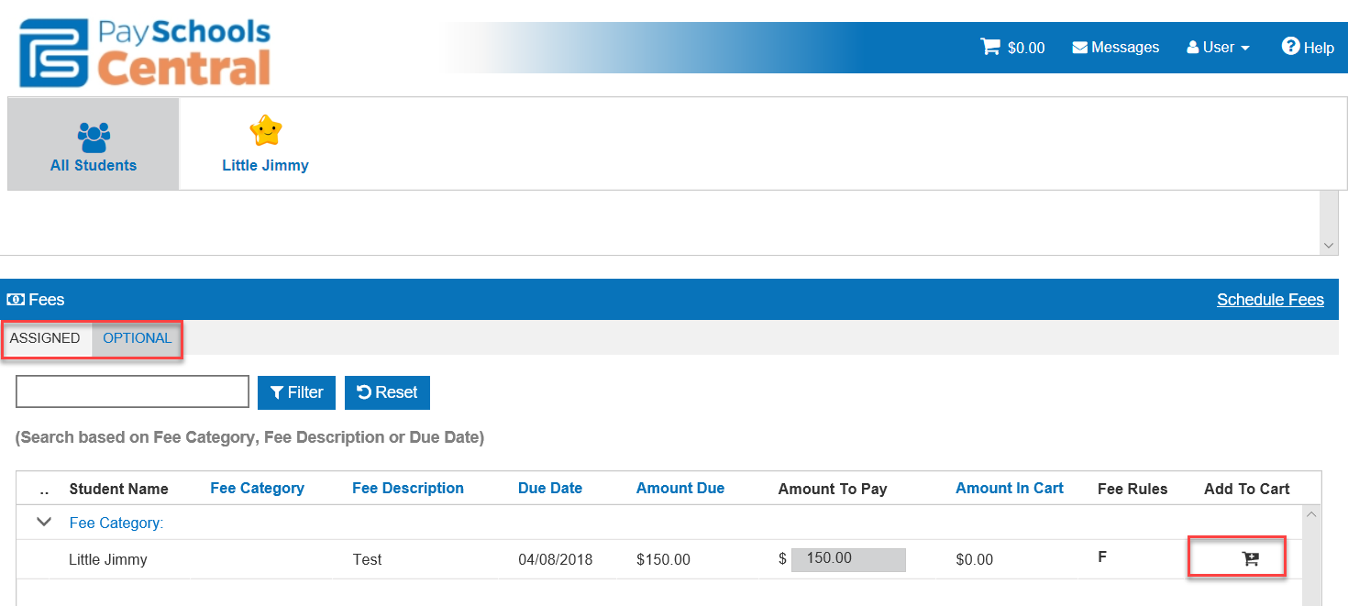

- Scroll down to the Fees section of the Home page and toggle between the Assigned and Optional fees available to your student. To add fees to your cart, click on the cart icon on the right side of the screen. You can add multiple fees for multiple students before checking out.

- You can decide to remove items from your cart before checking out by clicking the trash can icon under the cart icon at the top of your screen.
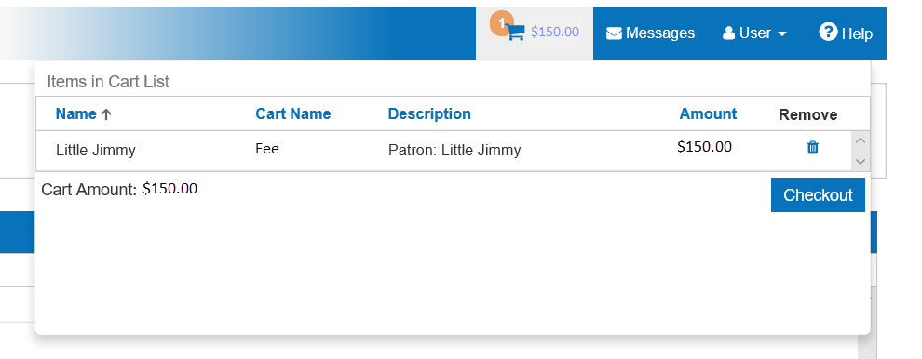
- From the Checkout pop-up, select your payment method and then press Submit Payment.

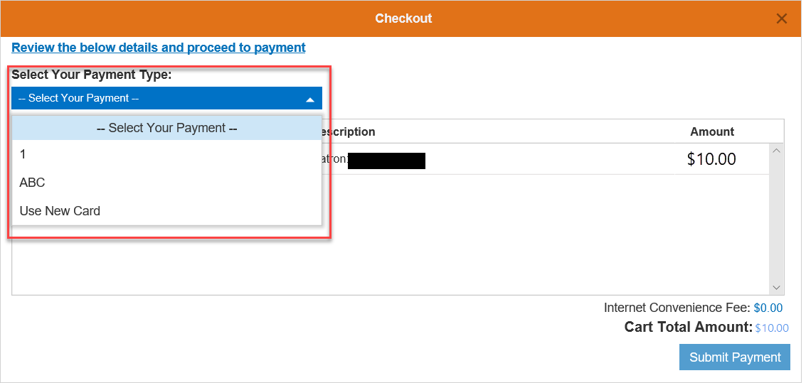

- After completing your purchase, you will receive an email with a receipt listing the item and amount of your transaction.
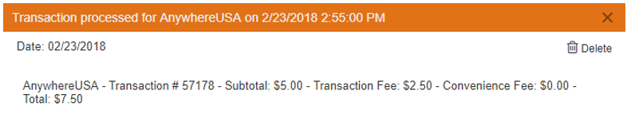

How Do I Schedule Fee Payments/Installments?

The fees associated with your account are set and maintained by your School District. The directions below will help you use the PayForIt.net application to pay for your fees.
Step 1 – Select Fees Schedule Fee Payment
- To set up Scheduled fees from the homepage, scroll down to Fees and choose Schedule Fee Payment
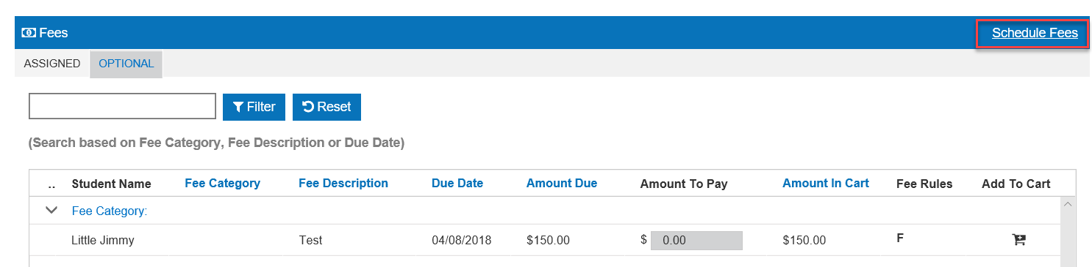

- To limit the list, choose a certain student and/or a certain date range.

- The fees existing on your account will display in the Fee Name drop down.

Step 2 – Choose Installment Payment Amounts and Dates

- Depending on the amount of installments allowed by your school, an Installment field will display for each payment.
- The installment payments can be set to any amount and date but must total the Amount Due and Payments fields must be completed before the due date.
- The system will allow the payments on the first day after the start date.
- In our example, the Amount must be paid within the time frame given
- Scheduled payments must be made before the due date

Payment History
- Payments can be viewed at any time, via the UserPayment History menu. Press the Trans ID link to show the details from a transaction.
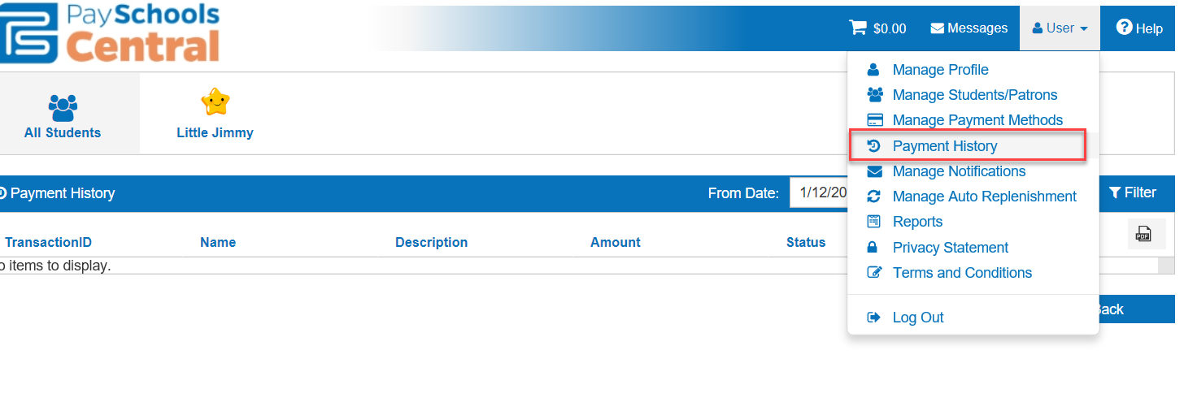

Running Reports

- From the User tab, open the Reports option.
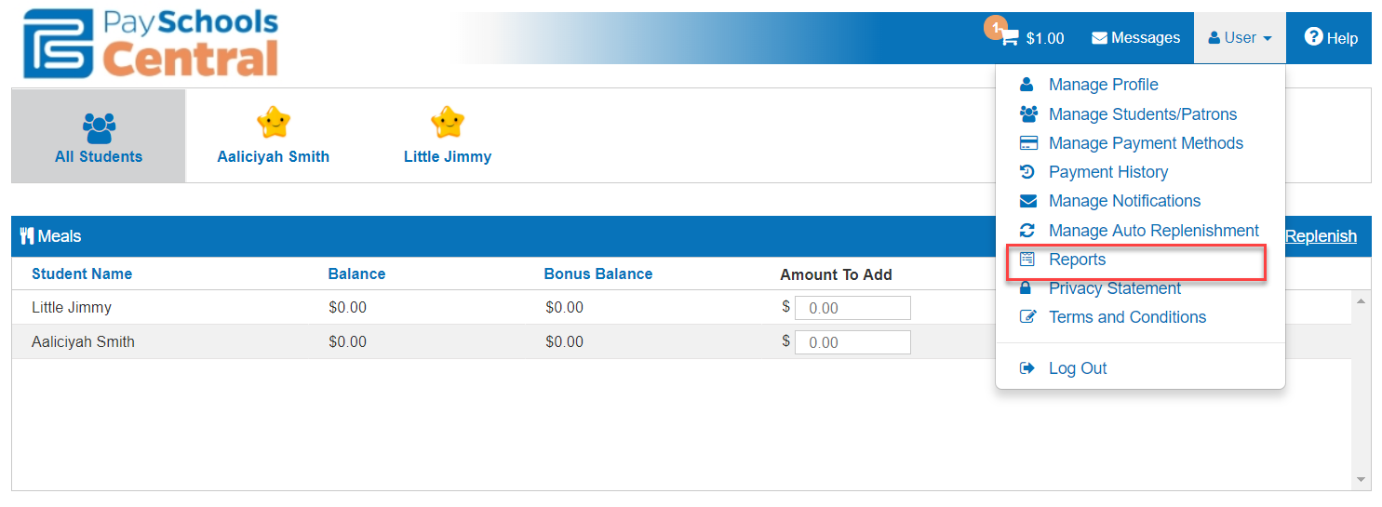
- NOTE: The reports in this section are contingent on the set up of your district. Not all schools and districts will have access to these reports.

Patron Account Activity Report

The first report is the Patron Meals Activity Report. Select you patron and your date range then, Generate Report.
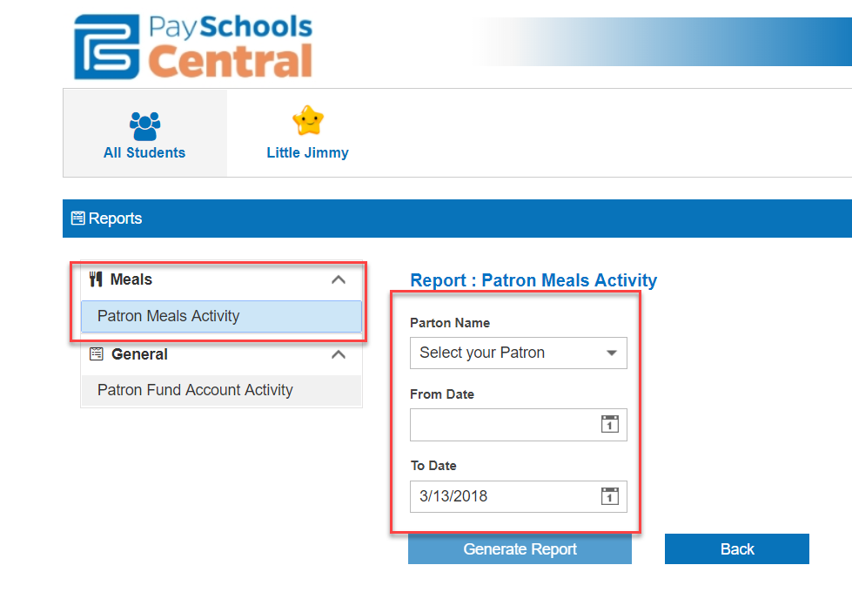

Patron Fund Account Activity

The next report is the Patron Fund Account Activity which will provide detailed account of child care
